Created by: David Rubio G.
Blog: https://soceame.wordpress.com/
GitHub: https://github.com/DRubioG
Last modification date: 09/03/25

This installation method is for Windows (but can also be applied on Linux).

License
To run Libero you need to have a license, for which there are several types of licenses. There are free ones (Silver license) and paid ones (the rest, the Gold one on floating node costs about 1350 euros).
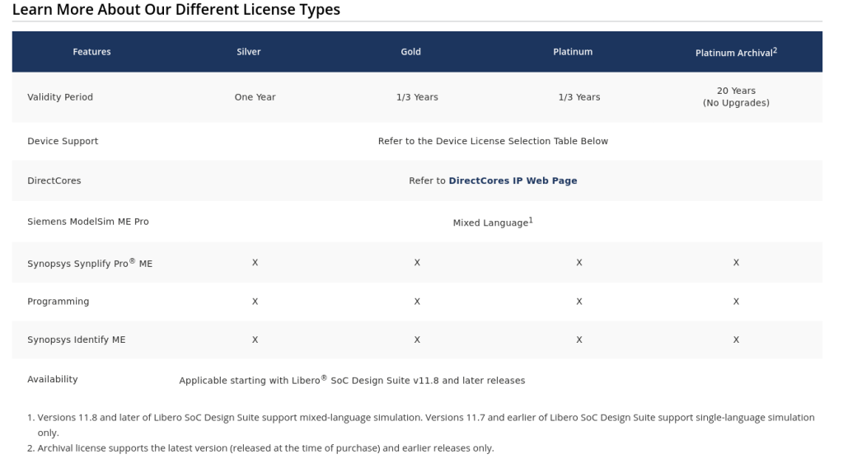
The free license has its limitations, such as the devices that can be programmed with it (some evaluation devices are not included in the Silver license, others are). Another limitation is the duration, the license lasts 1 year, but it can be renewed year after year completely free of charge. And it also limits the ability to use different languages ​​in a project, such as VHDL and Verilog in the same project.
To request the free license you only have to register at MicroChip and request the license. To do this, it will ask you for the serial number of the computer in Windows (in Linux it is a bit more complex, and I have not yet managed to get Libero to work in Linux).
To get the serial number we have to open the Windows Terminal/Command Prompt (not Windows PowerShell), and run the command:
vol C:
This will return the volume's serial number.
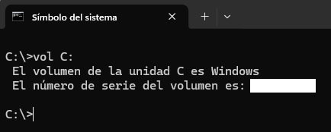
This is entered into Libero.
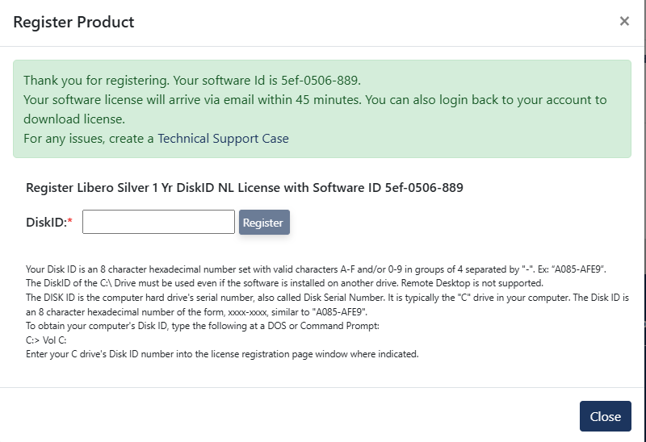
Libero will send you the license by email (in about 45 minutes), but you can also get it from the website, it is a .dat.
NOTE: the license is associated with the computer that has been requested, so you cannot use that license on other computers, but you can request another license associated with that new computer. Not all software requires having the license on the computer itself, they only require it to download it.

Installation (first part)
The first thing is to download the installer, for this on the Libero website, we will see several options, depending on whether we want to install only Libero (Web Installer), this takes up little space. Then we have the Full Installer, which allows us to download almost all Libero software (the only one that is not installed is the SoftConsole, which has to be downloaded manually). And then there is the Megavault, which is the installer to install Libero offline.
Note: I recommend installing the Libero Full Installer, because it contains FlashPro Express and therefore, there is no need to install it separately. From now on I will explain how to download the Full Installer.
FlashPro Express is the software that allows you to download the FPGA bitstream without having to open the development IDE (Libero).
NOTE: FlashPro does not require a license to install it, but it does need one to download it, but it is not associated with a computer like Libero, so it can be installed without needing a license on the computer.
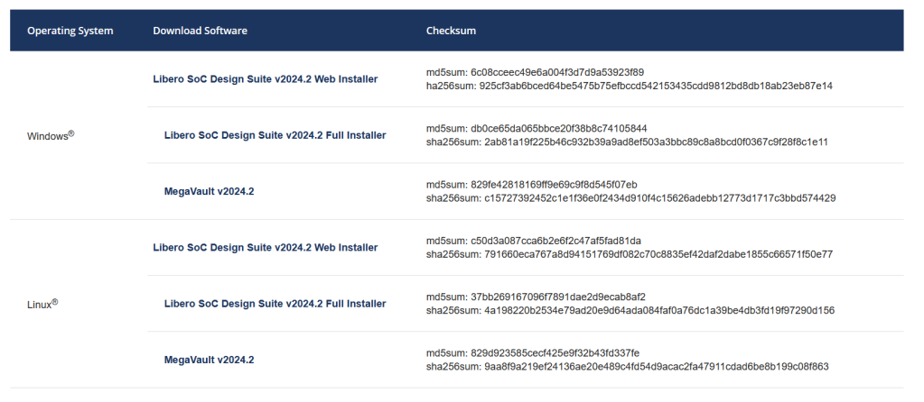
To download it you must have a MicroChip account, which will be requested now.
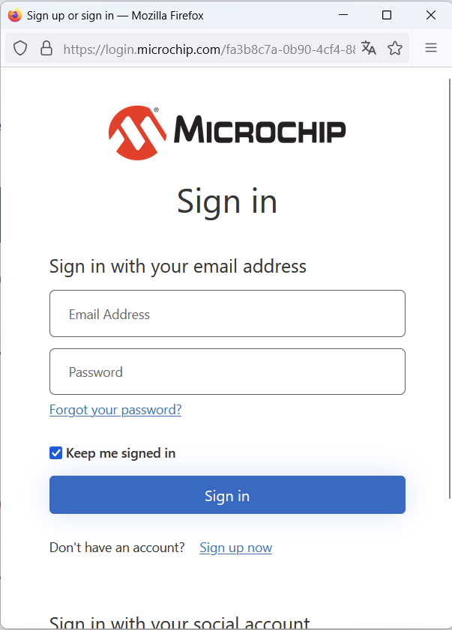
The installer looks like this.
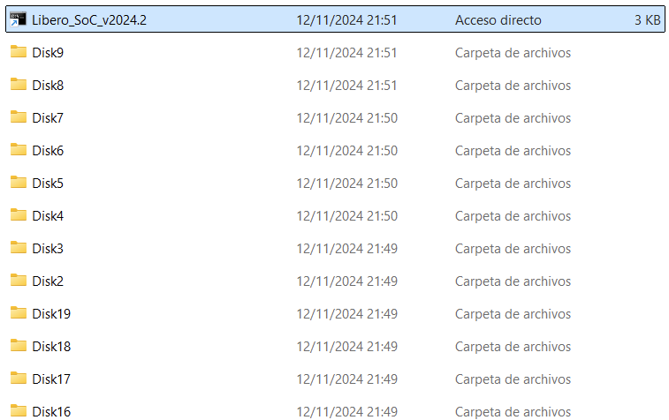
When you run it, the following tab opens, click Next.
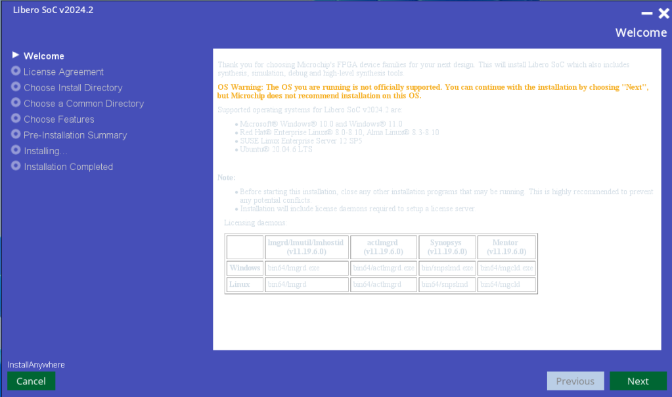
Then you will see the license terms, check the box and Next.
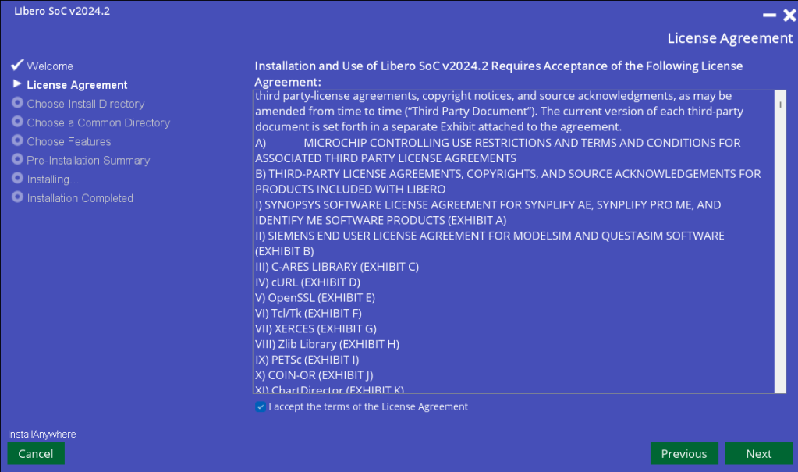
Then where you are going to save it, Next.
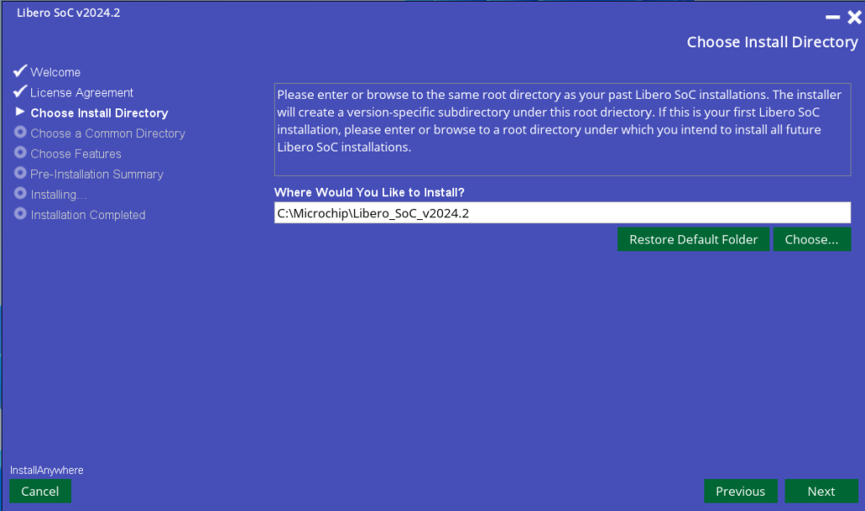
Then the Common directory, we put it inside the previous folder.
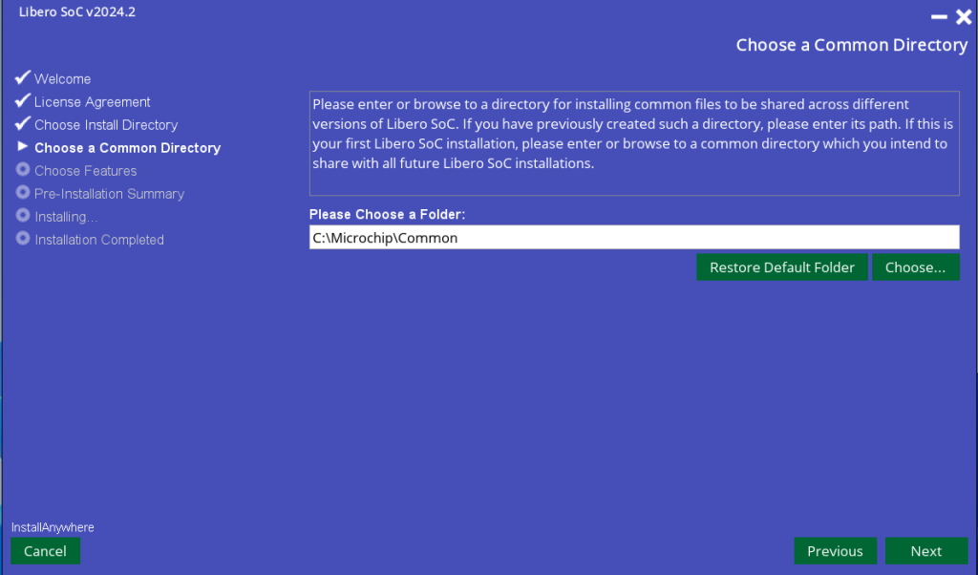
Then the software that we are going to install.
- Libero is the software that allows you to save MicroChip FPGAs
- Synplify Pro, Synopsis synthesis tool, which can be used to add logic analyzers to the design in Libero.
- Identify ME is the Synopsis analysis system for the previous logic analyzers.
- QuestaSim Pro, Siemens FW simulator.
- ModelSim, Siemens FW simulator (like the one integrated in Vivado, this is because Libero does not have a FW simulator inside, so it uses an external one)
Both QuestaSim and ModelSim work the same, and are from the same manufacturer.
- FlashPro, this program allows you to burn FPGAs without the need for Libero, it can be installed independently, it is very interesting to use it in FPGA production, it also allows the use of TCL commands.
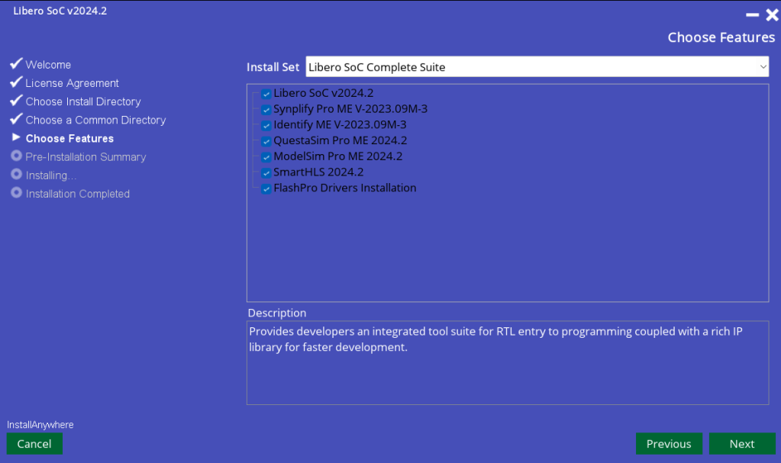
Then it shows you how much the installation will take up, in my case 25Gb (less than the full Vivado installation, which was around 300Gb in version 2024.1), Install.
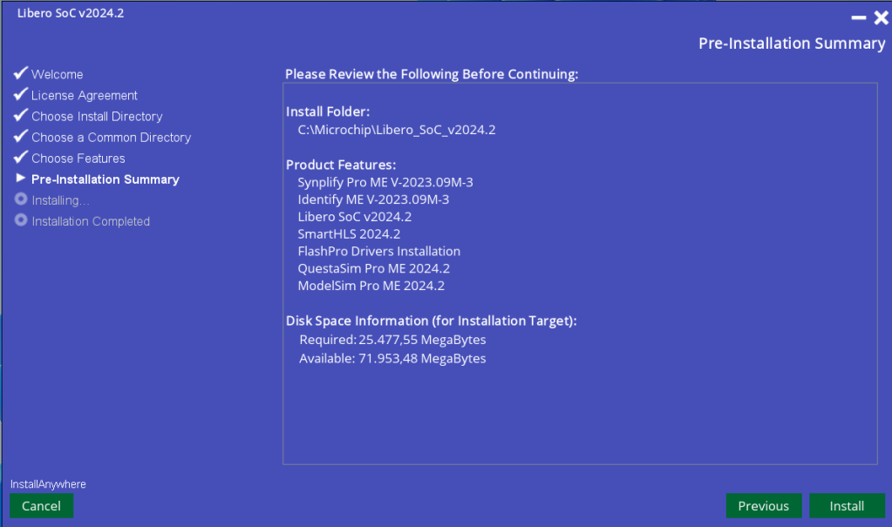
Next step: the installation is automatic.
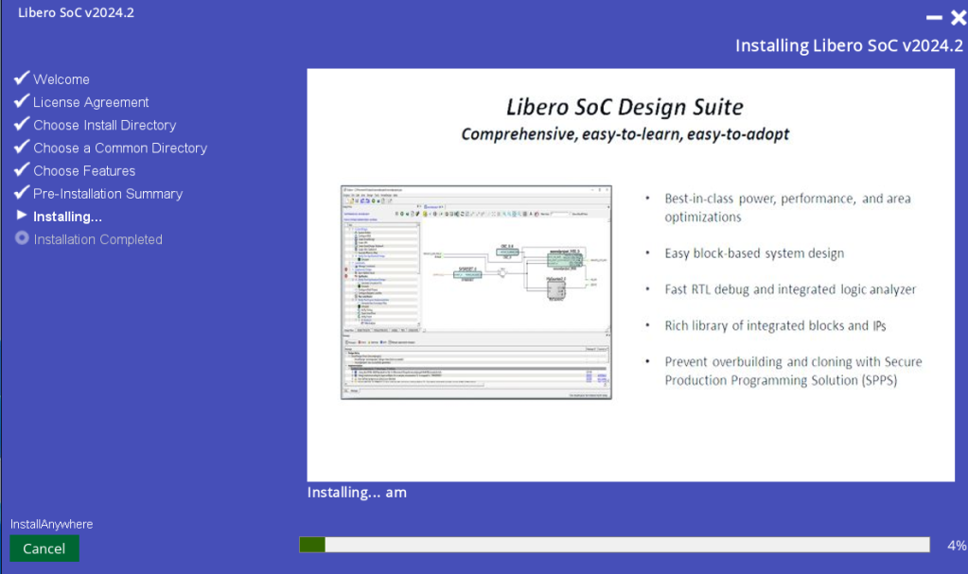
Last tab, close the installer (it does not offer us the option to open it automatically because there are several steps missing for it to be executed).
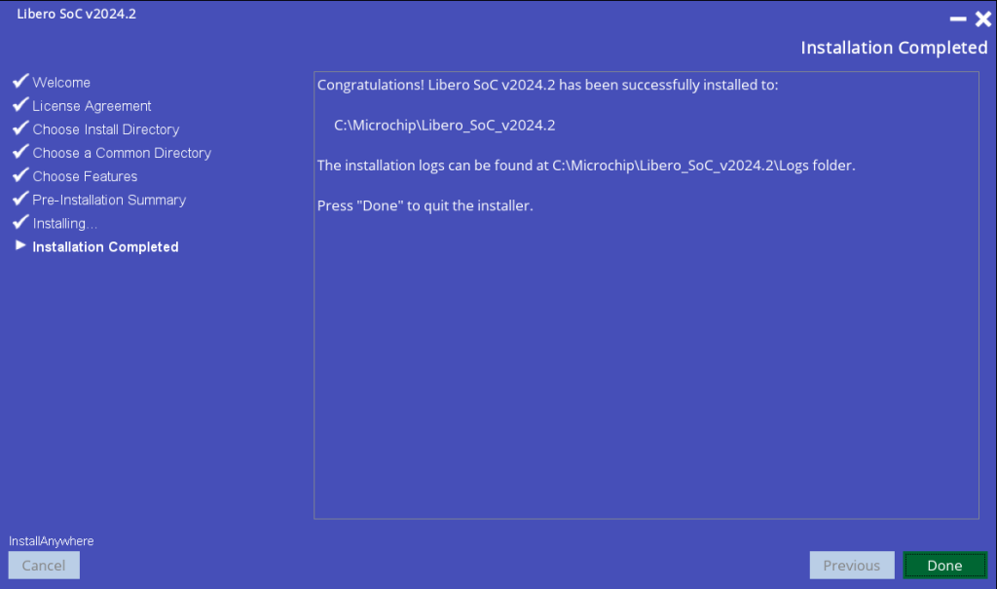

Installation (second part)
For this second part we need to have the license available.
The first thing we are going to do is create a folder in the base directory (C:) called «flexlm«, it would look like «C:\flexlm«.
In this folder we put the Libero license.
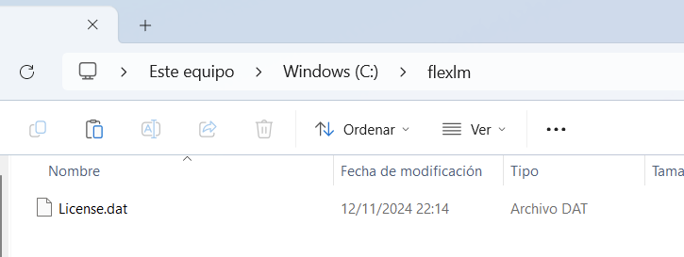
Once created, we have to create a system variable, to do this we open the system variable editor.
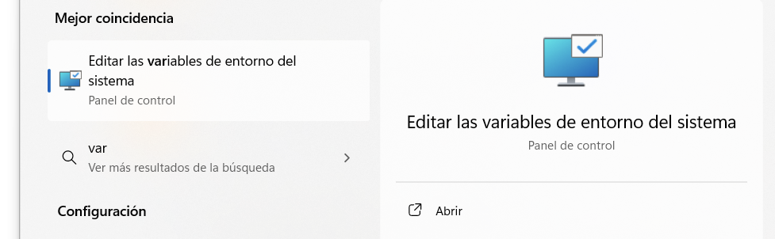
When opening it in «advanced options» there is an option called «Environment variables…»
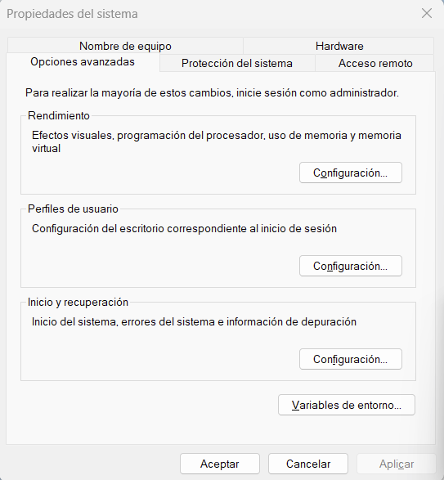
When clicking on it a tab opens where the variables are, then, in System variable (not User variable), we click on «New…» and create one called LM_LICENSE_FILE with the value of the license we have from Libero (in C:\flexlm\License.dat)
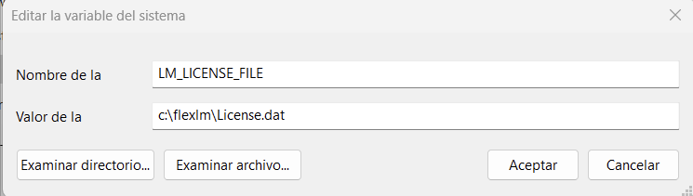
Once created we open the Microsemi License Utility tool.
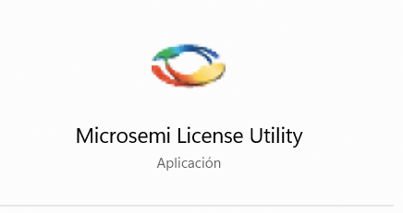
And in this tool we introduce the license from the directory where we have it.
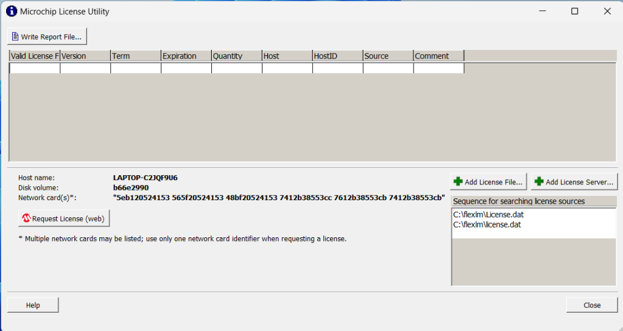
When you enter the license, it looks like this.
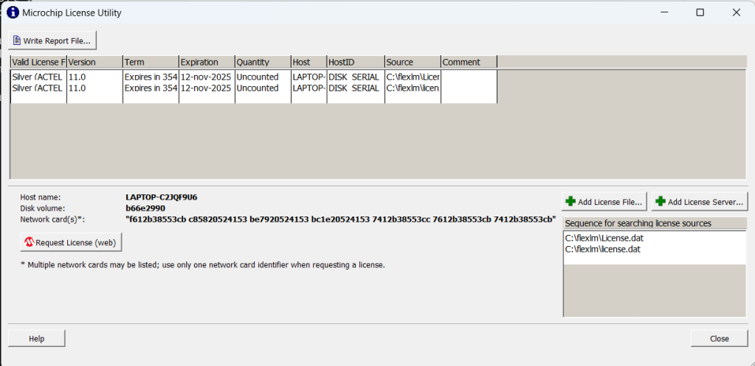
And with all this, you can now open Libero and its tools, except for the SoftConsole.

Installing the SoftConsole
The SoftConsole is the tool that MicroChip uses to program its SoCs, it is like Vitis (or Vivado SDK).
To install it, you just need to go to the SoftConsole page and download it.
IMPORTANT NOTE: since the 2022 version, the SoftConsole only supports RISC-V type processors from the PolarFire SoCs family. In previous versions, such as 2021, programming of the Cortex-M3 of the SmartFusion2 family is supported.
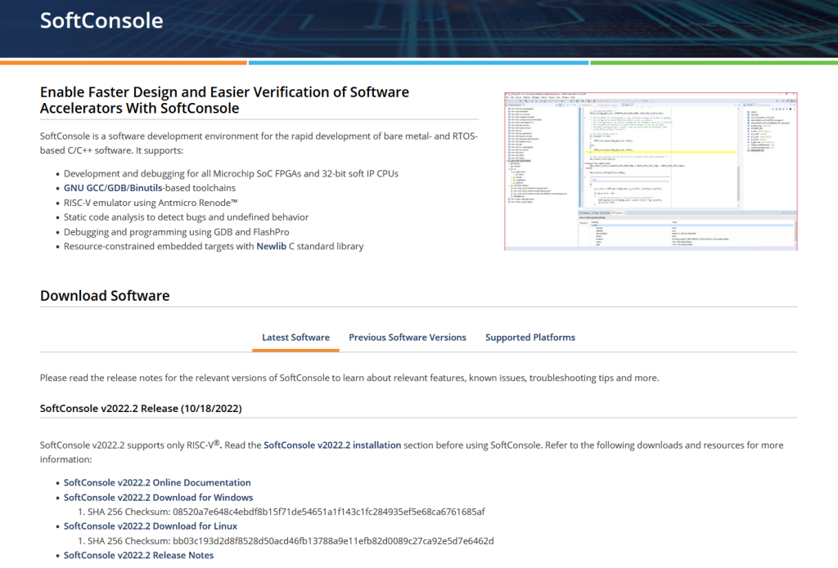
Once downloaded, a normal installation of the software is done.
